NAMA : Alvira Rhiza Ridwani

NIM : 19051397007

PRODI : D4 MI 2019 A

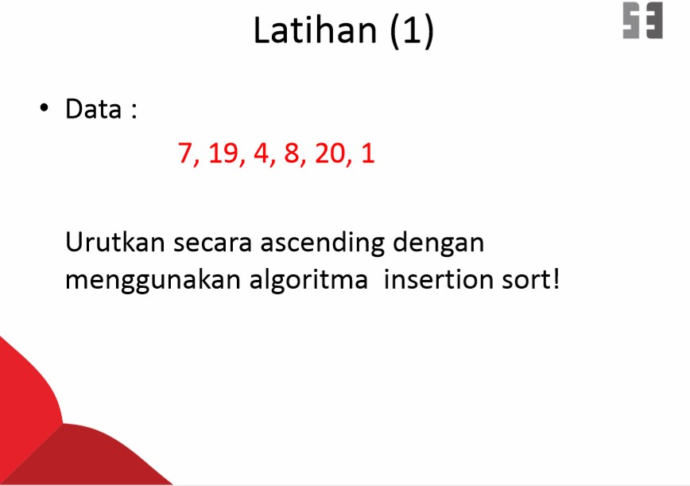

|  |  |  |  |  |  |  |
| --- | --- | --- | --- | --- | --- | --- |
| Proses | A[1] | A[2] | A[3] | A[4] | A[5] | A[6] |
| K=1: | 7 | 19 | 4 | 8 | 20 | 1 |
| K=2: | 7 | 19 | 4 | 8 | 20 | 1 |
| K=3: | 7 | 4 | 19 | 8 | 20 | 1 |
| K=4: | 4 | 7 | 19 | 8 | 20 | 1 |
| K=5: | 4 | 7 | 8 | 19 | 20 | 1 |
| K=6: | 4 | 7 | 8 | 19 | 1 | 20 |
| K=7: | 4 | 7 | 8 | 1 | 19 | 20 |
| K=8: | 4 | 7 | 1 | 8 | 19 | 20 |
| K=9: | 4 | 1 | 7 | 8 | 19 | 20 |
| K=10: | 1 | 4 | 7 | 8 | 19 | 20 |
| Urutan: | 1 | 4 | 7 | 8 | 19 | 20 |

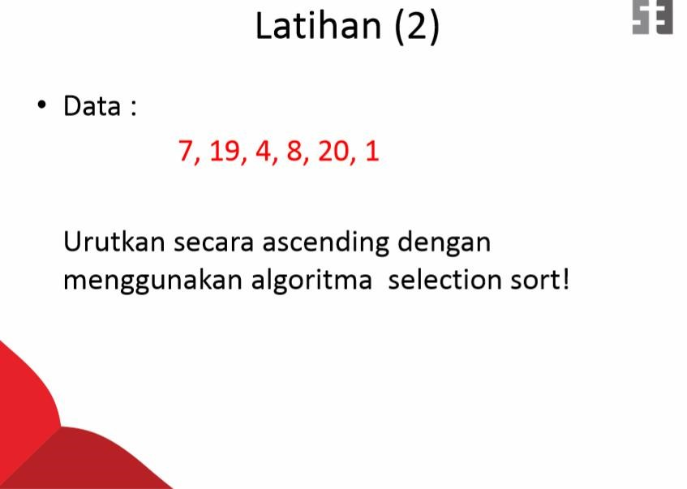

|  |  |  |  |  |  |  |
| --- | --- | --- | --- | --- | --- | --- |
| Proses | A[1] | A[2] | A[3] | A[4] | A[5] | A[6] |
| K=1 LOC=6 | 7 | 19 | 4 | 8 | 20 | 1 |
| K=2 LOC=3 | 1 | 19 | 4 | 8 | 20 | 7 |
| K=3 LOC=6 | 1 | 4 | 19 | 8 | 20 | 7 |
| K=4 LOC=6 | 1 | 4 | 7 | 8 | 20 | 19 |
| K=5 LOC=6 | 1 | 4 | 7 | 8 | 19 | 20 |
| Urutan : | 1 | 4 | 7 | 8 | 19 | 20 |

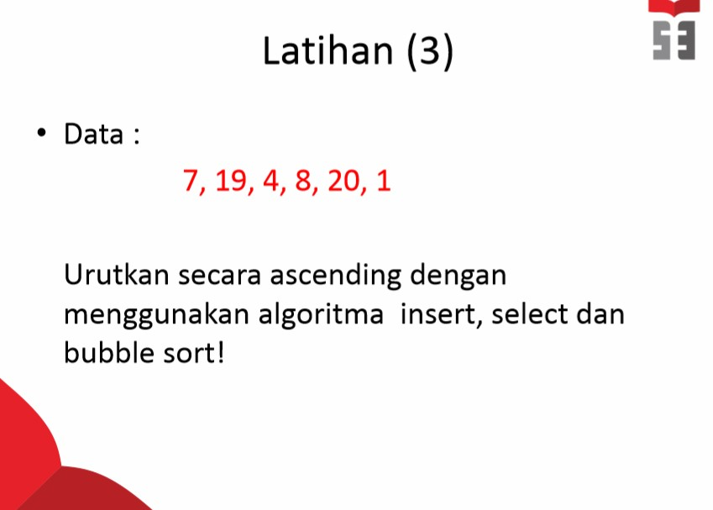

Pass pertama

(7, 19, 4, 8, 20, 1) menjadi (7, 19, 4, 8, 20, 1)

(7, 19, 4, 8, 20, 1) menjadi (7, 4, 19, 8, 20, 1)

(7, 4, 19, 8, 20, 1) menjadi (7, 4, 8, 19, 20, 1)

(7, 4, 8, 19, 20, 1) menjadi (7, 4, 8, 19, 20, 1)

(7, 4, 8, 19, 20, 1) menjadi (7, 4, 8, 19, 1, 20)

Pass Kedua

(7, 4, 8, 19, 1, 20) menjadi (4, 7, 8, 19, 1, 20)

(4, 7, 8, 19, 1, 20) menjadi (4, 7, 8, 19, 1, 20)

(4, 7, 8, 19, 1, 20) menjadi (4, 7, 8, 19, 1, 20)

(4, 7, 8, 19, 1, 20) menjadi (4, 7, 8, 1, 19, 20) (4, 7, 8, 1, 19, 20) menjadi (4, 7, 8, 1, 19, 20) Pass Ketiga

(4, 7, 8, 1, 19, 20) menjadi (4, 7, 8, 1, 19, 20)

(4, 7, 8, 1, 19, 20) menjadi (4, 7, 8, 1, 19, 20)

(4, 7, 8, 1, 19, 20) menjadi (4, 7, 1, 8, 19, 20)

(4, 7, 1, 8, 19, 20) menjadi (4, 7, 1, 8, 19, 20)

(4, 7, 1, 8, 19, 20) menjadi (4, 7, 1, 8, 19, 20)

Pass Keempat

(4, 7, 1, 8, 19, 20) menjadi (4, 7, 1, 8, 19, 20)

(4, 7, 1, 8, 19, 20) menjadi (4, 7, 1, 8, 19, 20)

(4, 1, 7, 8, 19, 20) menjadi (4, 1, 7, 8, 19, 20)

(4, 1, 7, 8, 19, 20) menjadi (4, 1, 7, 8, 19, 20)

(4, 1, 7, 8, 19, 20) menjadi (4, 1, 7, 8, 19, 20)

(4, 1, 7, 8, 19, 20) menjadi (1, 4, 7, 8, 19, 20)

(4, 1, 7, 8, 19, 20) menjadi (4, 1, 7, 8, 19, 20)

(4, 1, 7, 8, 19, 20) menjadi (4, 1, 7, 8, 19, 20)

(4, 1, 7, 8, 19, 20) menjadi (4, 1, 7, 8, 19, 20)

(4, 1, 7, 8, 19, 20) menjadi (4, 1, 7, 8, 19, 20)